CUSTOMER SEGMENTATION USING K-MEANS CLUSTERING
Submitted By
Name: Saurabh Pandey
Course: B.Tech (Information Technology)
Date: 05-07-2026

Table of Contents
- Title
- Problem Statement
- Dataset Description
- Data Preprocessing
- Exploratory Data Analysis
- Model Used
- Training Process
- Evaluation Metrics and Results
- Conclusion
- References
- Viva Questions

1. Title
Customer Segmentation using K-Means Clustering

2. Problem Statement
Customer segmentation is an important task in marketing and business analytics. Businesses collect large amounts of customer data but often struggle to understand different customer behaviors. Treating every customer the same leads to ineffective marketing strategies and reduced customer satisfaction.
The objective of this project is to group customers with similar characteristics using the K-Means Clustering algorithm. The segmentation is based on customer demographic and financial attributes such as Age, Gender, Annual Income, and Spending Score. By identifying different customer groups, businesses can create personalized marketing campaigns, improve customer retention, and maximize profits.

3. Dataset Description
The project uses the Mall Customers Dataset, which contains information about customers visiting a shopping mall.
Number of Records
- 200 Customers
Number of Features
- 5 Columns
Dataset Attributes
Attribute | Description
CustomerID | Unique customer identifier
Gender | Male or Female
Age | Customer's age
Annual Income (k$) | Annual income in thousand dollars
Spending Score (1–100) | Score assigned based on purchasing behavior

Target Variable
Since clustering is an unsupervised learning technique, the dataset does not contain any target variable or class label.

4. Data Preprocessing
Before applying the K-Means algorithm, the dataset was cleaned and transformed to improve model performance.
The following preprocessing steps were performed:
- Loaded the dataset using Pandas.
- Checked the dataset shape and column names.
- Verified data types of all attributes.
- Checked for missing values.
- Checked for duplicate records.
- Removed the CustomerID column as it does not contribute to clustering.
- Encoded the Gender column into numerical values using Label Encoding.
- Applied StandardScaler to normalize the dataset so that all features have equal importance.
Data preprocessing ensures that the clustering algorithm produces accurate and meaningful clusters.

5. Exploratory Data Analysis (EDA)
Exploratory Data Analysis was performed to understand customer characteristics before applying the clustering algorithm.
The following visualizations were created:
Age Distribution
The majority of customers belong to the age group between 20 and 40 years. Very few customers are above 60 years of age.
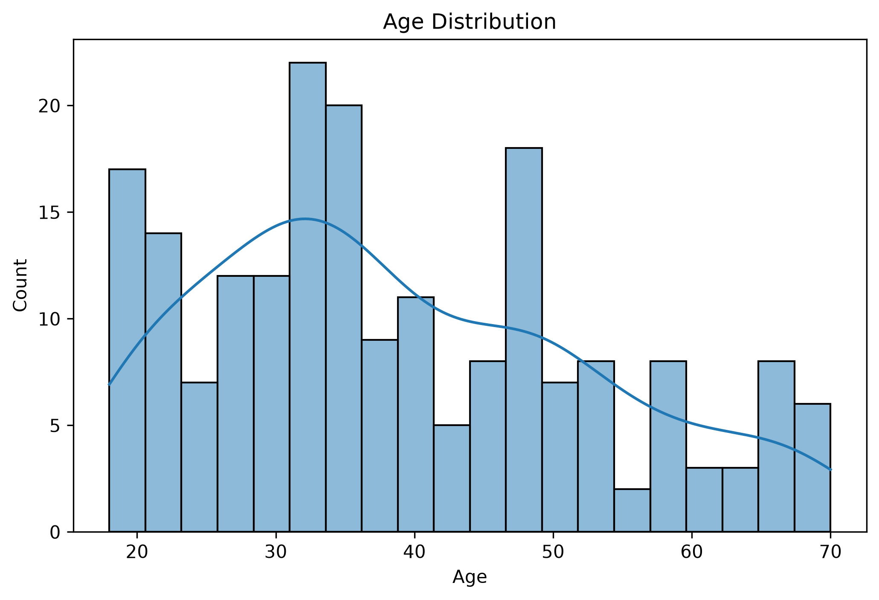

Gender Distribution
The dataset contains both male and female customers with a nearly balanced distribution, indicating that both genders are well represented.


Annual Income Distribution
Customers belong to different income groups ranging from low to high annual income, providing sufficient diversity for segmentation.

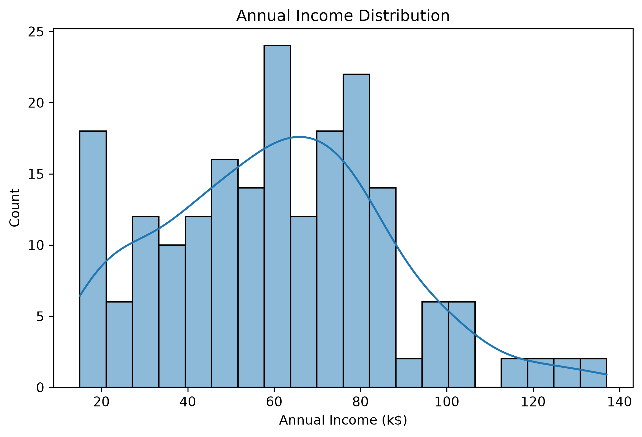Spending Score Distribution
The spending score varies significantly among customers, indicating different purchasing behaviors and making the dataset suitable for clustering.
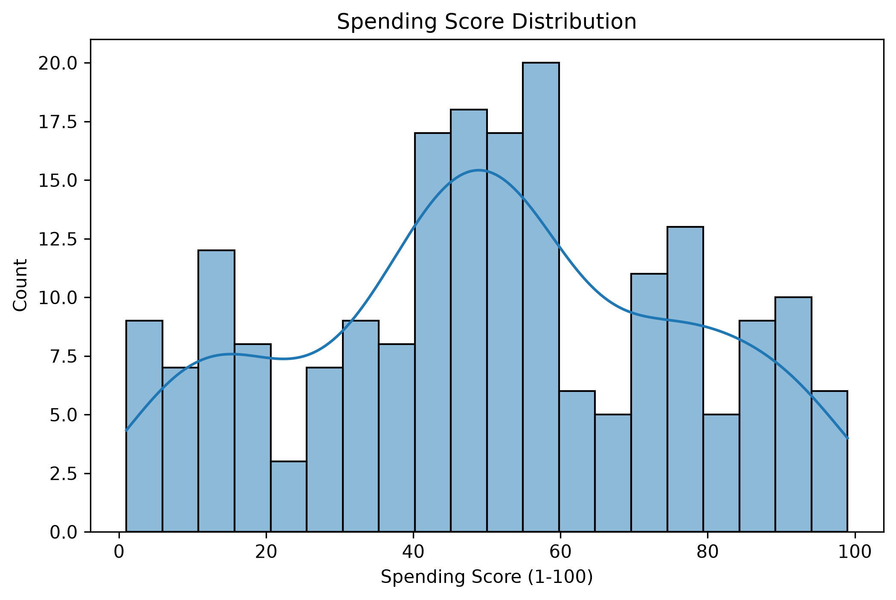
Correlation Heatmap
The correlation matrix shows that there is no strong linear relationship between most variables, which is expected in customer behavior datasets.
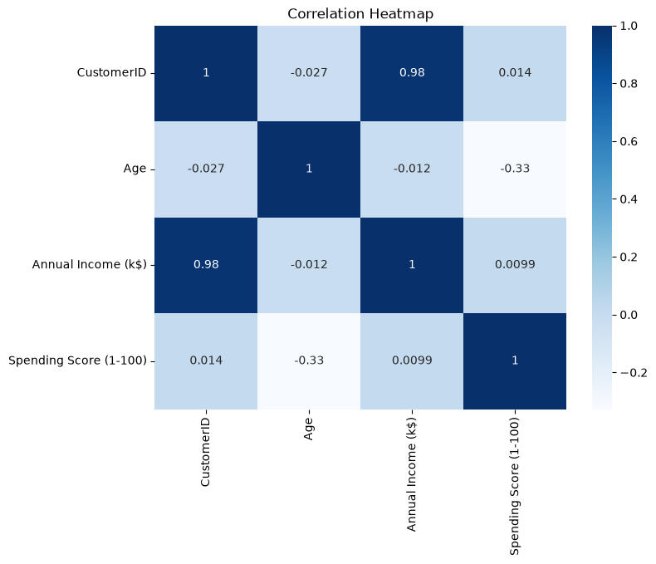
Pair Plot
The pair plot provides a visual understanding of the relationships among different features and highlights natural groupings in the data.
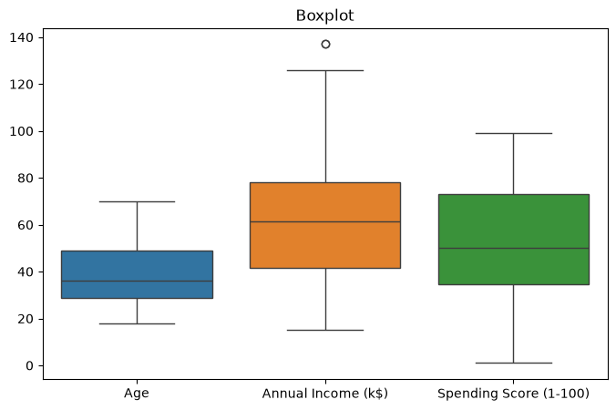

6. Model Used
The project uses the K-Means Clustering Algorithm, which is one of the most popular unsupervised machine learning algorithms.
Why K-Means?
- Simple to implement.
- Fast and computationally efficient.
- Works well with numerical data.
- Produces easily interpretable customer segments.
- Widely used in customer analytics and marketing.
Working Principle
- Select the number of clusters (K).
- Initialize K cluster centroids.
- Assign each customer to the nearest centroid.
- Update cluster centroids.
- Repeat until convergence. 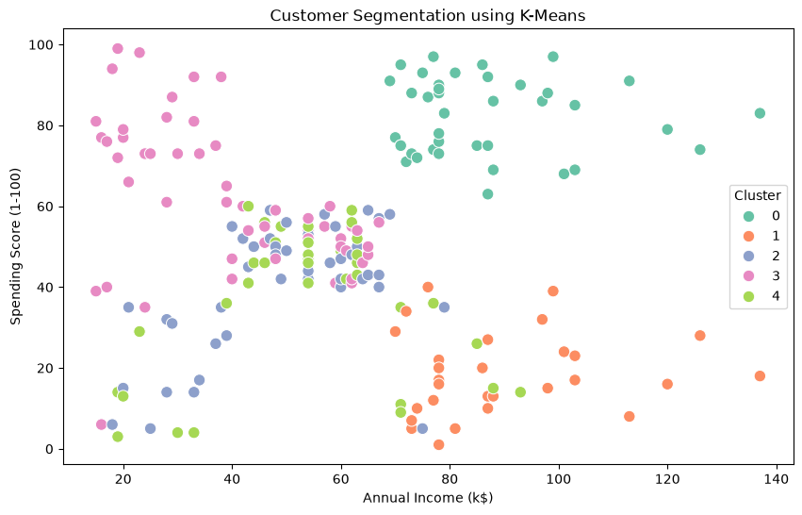

7. Training Process
The following steps were followed during model training:
- Import the dataset.
- Perform preprocessing.
- Standardize the features.
- Apply the Elbow Method to determine the optimal number of clusters.
- Select K = 5 based on the elbow graph.
- Train the K-Means model.
- Predict cluster labels for every customer.
- Visualize the clusters.
The model successfully grouped customers into five meaningful clusters based on their income and spending patterns.

8. Evaluation Metrics and Results
Elbow Method
The Elbow Method was used to determine the optimal value of K. The graph showed a clear bend at K = 5, indicating that five clusters are appropriate for this dataset.

Silhouette Score
The Silhouette Score was calculated to evaluate the quality of clustering. It measures how well each customer fits within its assigned cluster compared to other clusters. A higher score indicates better-defined clusters.
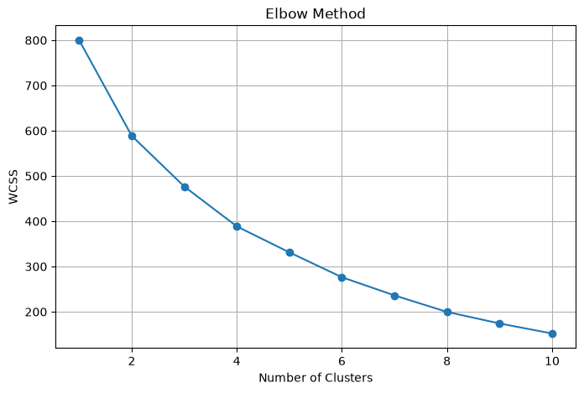

Cluster Visualization
The scatter plot of Annual Income versus Spending Score clearly shows five distinct customer groups, demonstrating that the K-Means algorithm effectively separated customers based on their purchasing behavior.


9. Conclusion
This project successfully applied the K-Means Clustering algorithm to segment customers into five different groups based on Age, Gender, Annual Income, and Spending Score.
The generated customer segments can help businesses identify high-value customers, design personalized marketing strategies, improve customer satisfaction, and increase overall business profitability.
The project demonstrates the practical application of unsupervised machine learning in business analytics and customer relationship management.

10. References
- Han, J., Kamber, M., & Pei, J. Data Mining: Concepts and Techniques. Morgan Kaufmann.
- Aurélien Géron. Hands-On Machine Learning with Scikit-Learn, Keras & TensorFlow. O'Reilly Media.
- Scikit-learn Documentation – https://scikit-learn.org
- Pandas Documentation – https://pandas.pydata.org
- Seaborn Documentation – https://seaborn.pydata.org
- Matplotlib Documentation – https://matplotlib.org
- Kaggle Mall Customers Dataset.

Q1. Semantic vs Instance vs Panoptic Segmentation
Semantic Segmentation | Instance Segmentation | Panoptic Segmentation
Classifies every pixel into a class. | Identifies each object separately. | Combines semantic and instance segmentation.
Does not distinguish between multiple objects of the same class. | Distinguishes different objects of the same class. | Provides both class information and object identity.
Example: Road detection. | Example: Counting individual cars. | Example: Autonomous driving scene understanding.

Q2. What is Fuzzy Logic? How is it different from Boolean Logic?
Fuzzy Logic is a reasoning approach that allows partial truth values between 0 and 1. Instead of only True or False, fuzzy logic supports degrees of truth.
Difference between Boolean Logic and Fuzzy Logic
Boolean Logic | Fuzzy Logic
Only True or False | Values between 0 and 1
Binary decisions | Gradual decisions
Rigid | Flexible
Used in digital circuits | Used in intelligent control systems
Example:
- Boolean Logic: Temperature is Hot (Yes/No)
- Fuzzy Logic: Temperature is 70% Hot

Q3. Customer Dataset Questions
1. Is this supervised or unsupervised learning?
This is an unsupervised learning problem because the dataset does not contain predefined output labels. The objective is to discover hidden customer groups based on similarities in Age, Annual Income, and Spending Score.
2. Which clustering algorithm would you choose first and why?
I would choose the K-Means Clustering algorithm because it is simple, efficient, and well-suited for numerical datasets. It performs well on customer segmentation tasks, is easy to implement, and provides clear and interpretable clusters for business analysis.
3. What assumptions does K-Means make about the data?
The K-Means algorithm assumes that:
- The number of clusters (K) is known in advance.
- Clusters are approximately spherical in shape.
- Data points are assigned to the nearest cluster centroid using Euclidean distance.
- Features are numerical and preferably scaled.
- Clusters have similar variance and are reasonably balanced in size.

